DOCUMENTATION - PLANT MONITOR

TEAM MEMBERS

Shreya Vaidyanathan - 2013115108
Tejal Satish - 2013115113

INTRODUCTION

This Arduino-based monitor lets you know if your indoor plants are getting enough water and light.
The Leaf Light consists of a soil moisture sensor, light sensor, and multicolored LED/NeoPixel connected to an Arduino that sits in or near a plant. It's surrounded by a frosted plexiglass container, which makes it an attractive light, and glows different colors based on the status of your garden. Here's what the colors mean:
Translating the Light
- Green: Everything is great! Soil moisture and light are at or above desired levels
- Blue: Water your plant. The soil is dry.
- Orange: Give your plant more light. It hasn't gotten enough today.
- Red: Your plant needs some love. Water the plant and give it some more light.
- White: Error. Check your connections and Arduino (not shown).

MATERIALS NEEDED:
Main pieces:
- Arduino
- Mini breadboard
- Digital Light Sensor or similar
- Neo pixel mini PCB
For the soil moisture sensor:
- galvanized steel screws or galvanized nails
- 10K ohm resistor
For the light case:
- clear acrylic sheet
- hot glue sticks
- sandpaper
- container to hold arduino
For the circuits:
- 22-Gauge, solid core wire in a variety of colors and/or breadboarding wires
- 60/40 rosin-core solder (.032" diameter or similar)
Other:
- Blue painters tape or other easily removable tape
- Several containers of dirt (used to test different soil moistures and calibrate your sensor)
- An indoor plant

Tools:
- Soldering iron with pencil tip
- Wire stripper
- Plier
- Glass cutter
- Ruler
- Marker
- Laptop + Arduino IDE

STEPS :

i. Assemble the soil moisture sensor
There are three different components that we are going to attach to our Arduino: a soil moisture sensor, a light sensor, and a NeoPixel light. All three have some sort of assembly or set up needed before they can be connected.

Soil Moisture Sensor
- Cut two pieces of 22-gauge, solid core wire. I used red and black to keep track of which wire will be connected where (red will be connected to 5V/the power source and black to ground). Estimate the length you think your sensor will need to travel from the Arduino.
- Strip the coating off of both ends of using the wire stripper. One side should be long enough to wrap several times around your screw/nail and the other long enough to fit into a pin in your Arduino or breadboard.
- Wrap the long end of uncovered wire just under the head of the screw or nail. You want it to be wrapped pretty tightly, because it needs to maintain a connection with the wire.
- The two nails cannot touch and need to maintain a stable distance from each other. I molded some Sugru I had on hand around the two nails to keep them apart at the same distance. I have also seen this achieved with a square of styrofoam.

ii. Assemble the light sensor
- Cut four pieces of 22-gauge, solid core wire.
- Strip both ends of each wire using the wire stripper, enough for one end to go into the Arduino/breadboard and the other end to go through the spots on the sensor.
- Poke the end of each wire through the hole you will be soldering it to (see the earlier mention of color coding). Once the wire is through, bend it at a 90-degree angle under the sensor so the remaining wire is parallel to the face of the sensor.
- Solder the end of each wire to the sensor.
- Use the flush diagonal cutter to cut off the excess wire flush to your solder joints.

Build the circuit
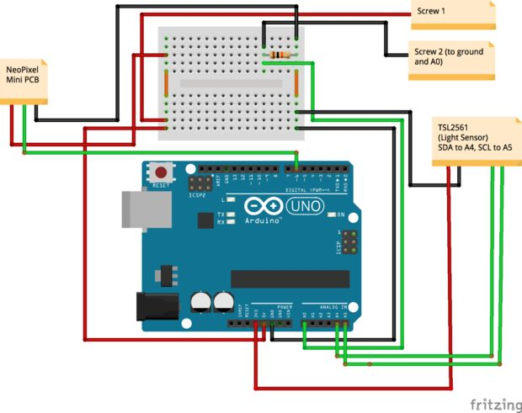
Use two breadboarding wires to connect one line of the breadboard to 5V and another line to Ground.
- Use a small wire to connect the lines horizontally. Now any time you need power, you can take it from the power row and any time you need to connect to ground, you can tap into the ground row.
- Moisture sensor. One wire (red) goes in the 5V row on the breadboard. The other (black) goes into a new row on the breadboard. Use the 10K ohm resistor to connect to ground and another breadboarding wire to connect to A0 (Analog pin 0).
- Light sensor. Connect Vin (red) to 3.3V on the Arduino (not the breadboard). Connect GND to ground on the breadboard. Connect SDA (green) to A4 (Analog pin 4) and SCL (green) to A5 (Analog pin 5).
- NeoPixel. 5V/+ (red) connects to 5V on the breadboard. gnd/- (black) connects to ground on the breadboard. Din (green) connects to D6 (Digital pin 6)

iii. Set up the Arduino and test the circuit

iv. Upload the full Leaf Light sketch and calibrate sensors

We need to have the arduino IDE installed as the primary step, this is a free open source software that we are going to use to write, edit and upload code or “sketches” to our arduino. As a part of setting up the arduino, it is cutomary to download, setup and install several additional arduino libraries.
- Adafruit NeoPixel
- Adafruit Sensor
- Adafruit TSL2561 U
- Time
- Time Alarms

Create the code 'plantmonitor.ino' to be uploaded in the arduino.

Once the components of the hardware and sensors are ready, we need to integrate it with the IDE.

EXISTING PROJECT REFERENCES

This project was initially designed by 'Making and Makerspaces' which is part of the master of library and Information Science Program at Saint Catherine University. For our socially relevant project, we have adopted ideas from them and tried to improvise the implementation. Their project had made use of a microcontroller, but we chose to incorporate the arduino in ours.

These were several projects from which we have studied extensively and borrowed from to create this project :

- Erbbie – Desktop Smart Garden by zacharyianhoward.
- Garduino – Gardening + Arduino and potted plant protector (Make Magazine) by liseman.
- Moisture detection with two nails and Soil/Moisture detection system by ronnietucker.
- Twitter mood light (used for light box design and neopixel instructions) by randommatrix

